Lab: Atomic Widgets

In this lab, you will first investigate the properties of input widgets using the PCF Format Reference and answer some questions about specific widget properties. Then, you will create a new set of atomic widgets for an existing detail view.

Requirements

This lab requires that you use TrainingApp 8.0, Guidewire Studio 8.0, and Chrome as your web browser. To view, edit, and delete various contacts, log in to TrainingApp as Alice Applegate. The default URL for TrainingApp is <http://localhost:8880/ab/ContactManager.do>. The login/password for Alice Applegate is aapplegate/gw.

1. Investigate Widget Properties

In this exercise, you will use the PCF Format Reference to investigate various widget properties.

Investigation

1. Open the PCF Format Reference
2. In Chrome, open the pcf.html file from the C:\<installDirectory/>\TrainingApp\modules\ directory.
3. Review the BooleanRadioInput widget properties
4. Use the Quick Jump drop-down list to select the BooleanRadioInput widget.
5. Review the widget properties.
6. Review the DateInput widget properties
7. Use the Quick Jump drop-down list to select the DateInput widget.
8. Review the widget properties.
9. Review the TextInput widget properties
10. Use the Quick Jump drop-down list to select the TextInput widget.
11. Review the widget properties.
12. Review the TypeKeyInput widget properties
13. Use the Quick Jump drop-down list to select the TypeKeyInput widget.
14. Review the widget properties.

Write it down

When a user attempts to modify the Is Verified widget value, a dialog box opens. The dialog box asks the user to confirm the change. What is the name of the attribute (property) for a BooleanRadioInput that displays a confirmation message in a dialog box?

|  |
| --- |
|  |

The label for the Evaluation Date must be in bold in the user interface. What is the name of the attribute (property) for a DateInput that allows a configurator to implement a bold style for the label?

|  |
| --- |
|  |

When a user hovers over a Legacy Code text input widget with their mouse cursor, the user interface displays, "The code must come from the legacy claim system." What is the name of the attribute (property) for a TextInput that displays this message?

|  |
| --- |
|  |

The Interaction Reason type key input must be no wider than 50 pixels when in edit mode. What is the name of the attribute (property) for a TypeKeyInput that defines the width?

|  |
| --- |
|  |

Exercise 2: Create new atomic widgets

In this exercise, you will create new atomic widgets to capture and display additional contact details for an existing details view.

Configuration

1. Open Guidewire Studio
2. Run or Debug the TrainingApp project
3. Use the main menu, toolbar, or keystroke to run or Debug the server.
4. Verify that the Run or Debug Console tab shows ***** ContactManager ready *****.
5. Log in to TrainingApp
6. Log in as Alice Applegate.
7. View the William Andy Summary
8. Search for William Andy.
9. In the search results list view, navigate to the William Andy contact.
10. Open the Summary Page in Guidewire Studio
11. Use the appropriate internal tools shortcut to open the PCF file in Guidewire Studio.
12. Open the ABContactSummaryDV
13. In the PCF Editor, open the ABContactSummaryDV.pcf file.
14. In the canvas, hide included sections.
15. Add widgets to the Detail View Panel
16. Use the Toolbox to add widgets below the AddressOwnerInputSet.
17. Select the input widget to best display and edit the field. If in doubt about the widget type, use the Input widget.
18. Use the Properties window to define the necessary widget properties when such as id*, editable, and value*.
19. When defining labels, create display keys.
20. Add the following widgets:

|  |  |  |  |  |
| --- | --- | --- | --- | --- |
| Order | Widget | Label | anABContact field | Editable |
| 1 | Input Divider |  |  | n/a |
| 2 | Label | Contact Analysis |  | n/a |
| 3 | An input widget | Contact Tier | Contact Tier | Yes |
| 4 | An input widget | Customer Rating | Customer Rating | Yes |
| 5 | An input widget | Strategic Partner | Strategic Partner | Yes |
| 6 | An input widget | Last Courtesy Contact | Last Courtesy Contact | Yes |
| 7 | An input widget | Fraud Investigations | Number Of Fraud Investigations | No |
| 8 | An input widget | Web Address | Web Address | Yes |

Verification

1. Reload the PCF changes
2. In TrainingApp, reload the changes to the PCF file(s) and display keys.
3. Verify your changes on the Summary page for William Andy.

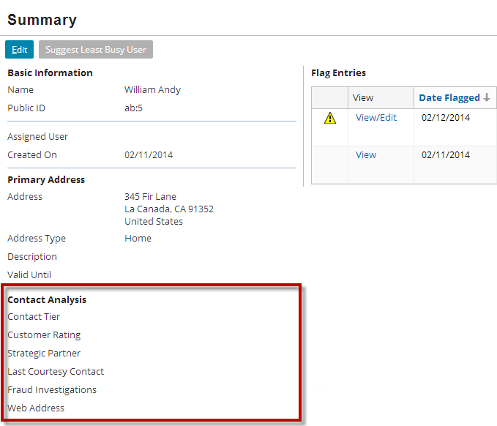

|  |  |
| --- | --- |
|  | Stop and ask your instructor to review your completed lab. |